Full Title - The Title Should Be Centred
(Arial 14)

Presenting Author (Arial 10 Bold), Co-Authors (Arial 10)
Organization, Address, City, Country (Arial 9)
Contact@E-mail (Arial 9)

Abstract (Arial 10)

ONE page abstract format: including figures and references.
Do not change the font sizes or line spacing to squeeze more text into a limited number of pages.
Please follow the model below.
Single-spaced and a single paragraph
Page margins are 1,90 cm left and right.
Greek letters, sub- and superscripts should be formatted as such.

References

- Authors, Journal, Issue (Year) page (Arial 10) Indicate references with sequential numbers within [square brackets].
- Authors, Journal, Issue (Year) page (Arial 10) Indicate references with sequential numbers within [square brackets].
- Authors, Journal, Issue (Year) page (Arial 10) Indicate references with sequential numbers within [square brackets].
- Authors, Journal, Issue (Year) page (Arial 10) Indicate references with sequential numbers within [square brackets].

Figures



Figure 1: Insert caption to place caption below figure (Arial 9)

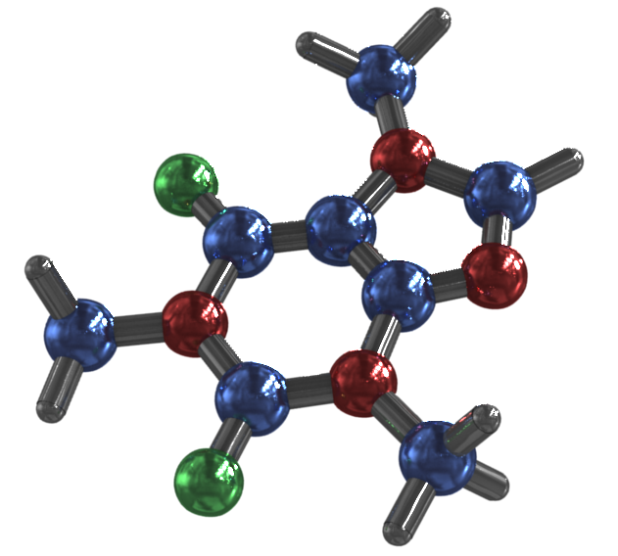

Figure 2: Insert caption to place caption below figure (Arial 9)

